PHP ASSIGNMENT

**TOPIC – SQL TASK 1**

TABLE: - EMPLOYEE

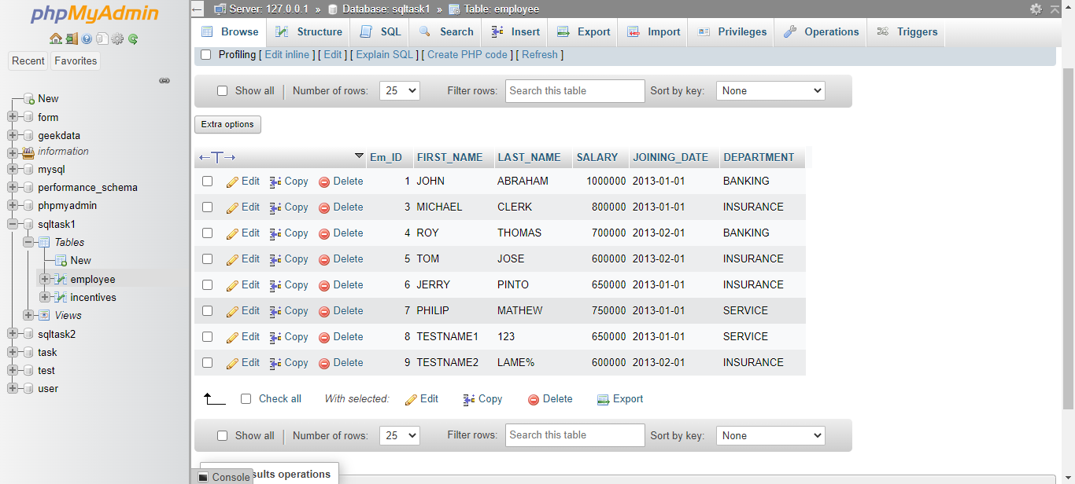

TABLE: - INCENTIVES

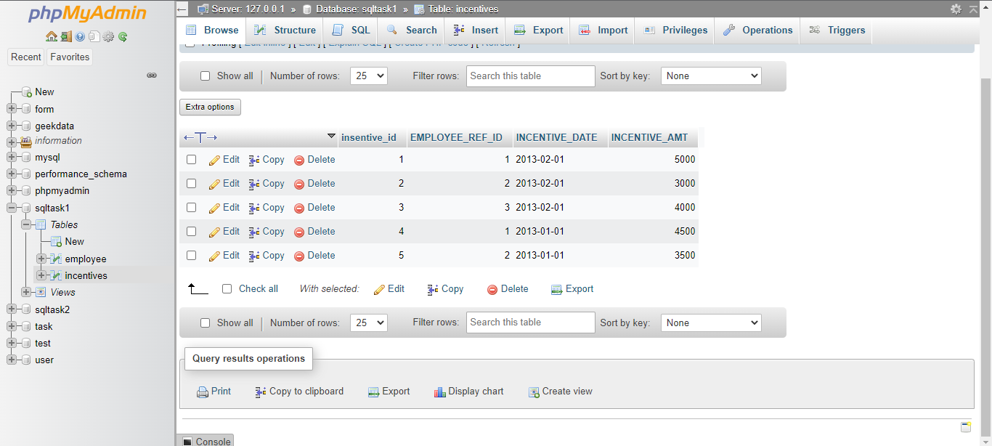

1. Get First_Name from employee table using alias name “Employee Name”.

Ans: - SELECT FIRST_NAME AS "EMPLOYEE NAME" FROM employee;

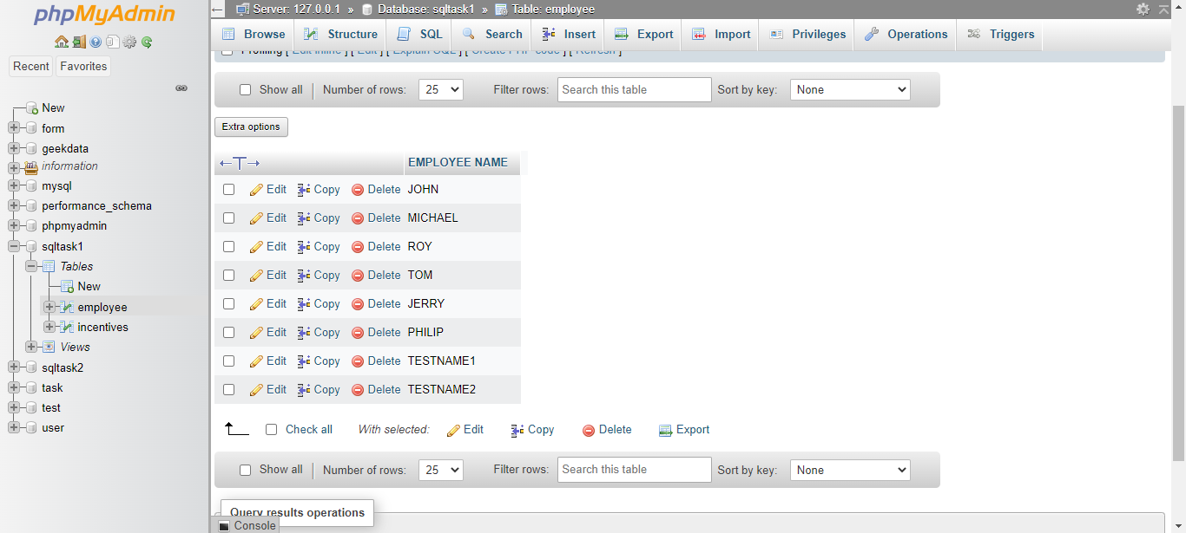

1. Get FIRST_NAME, Joining year, Joining Month and Joining Date from employee table.

Ans: - SELECT FIRST_NAME, YEAR(JOINING_DATE), MONTH(JOINING_DATE)

DAY(JOINING_DATE) FROM employee WHERE 1;

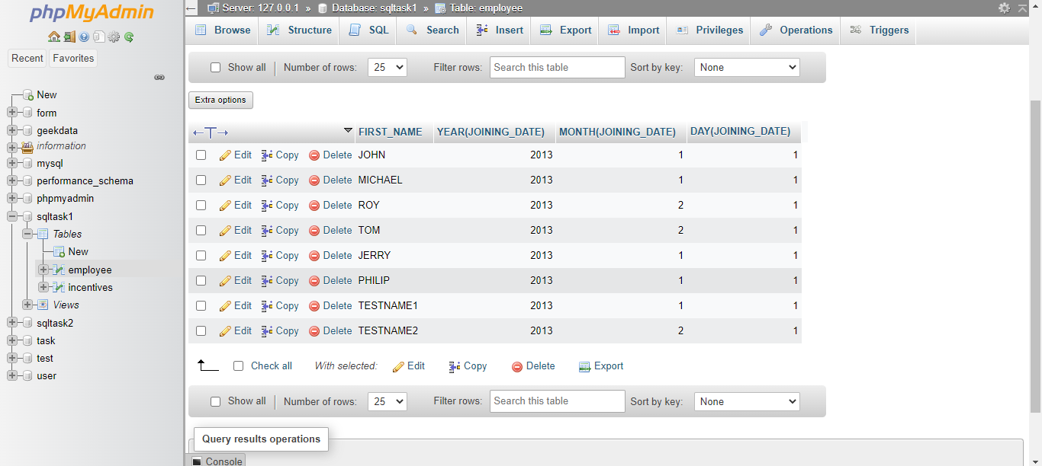

1. Get all employee details from the employee table order by First Name Ascending And Salary descending?

Ans: - SELECT * FROM `employee` ORDER BY SALARY ASC;

SELECT * FROM `employee` ORDER BY SALARY DESC;

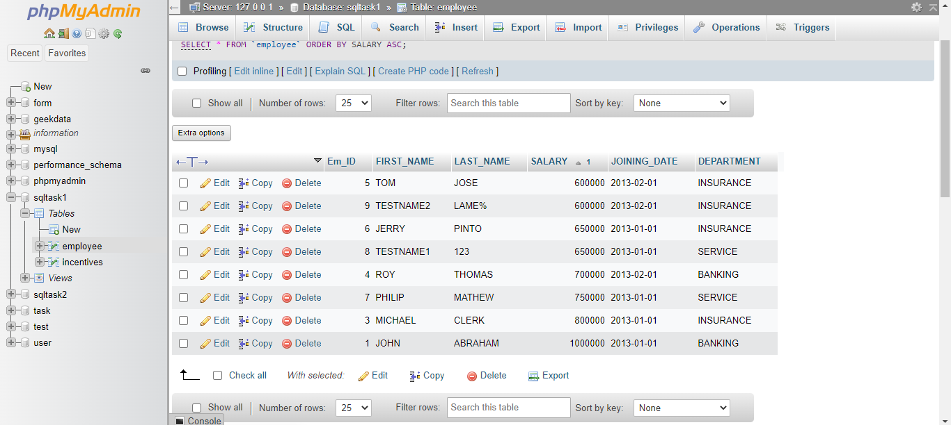

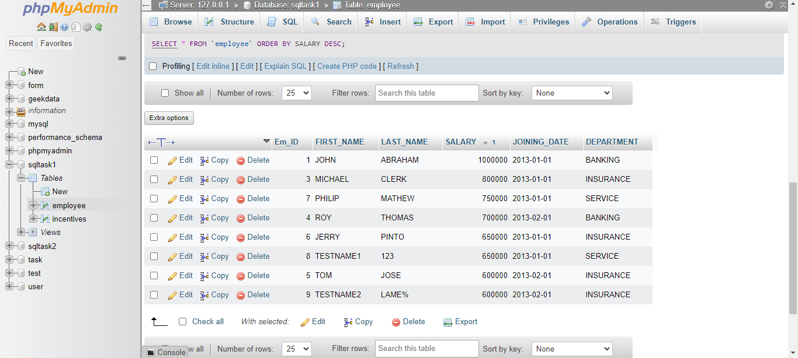

1. Get employee details from employee table whose first name contains „o‟.

Ans: - SELECT * FROM employee WHERE FIRST_NAME LIKE '%o%';

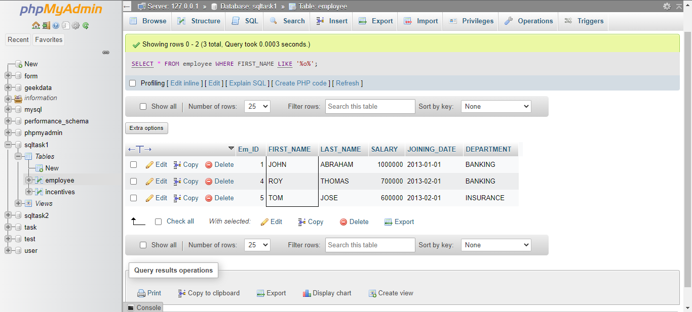

1. Get employee details from employee table whose joining month is “January”.

Ans: - Select * from employee where month(joining_date)='01'

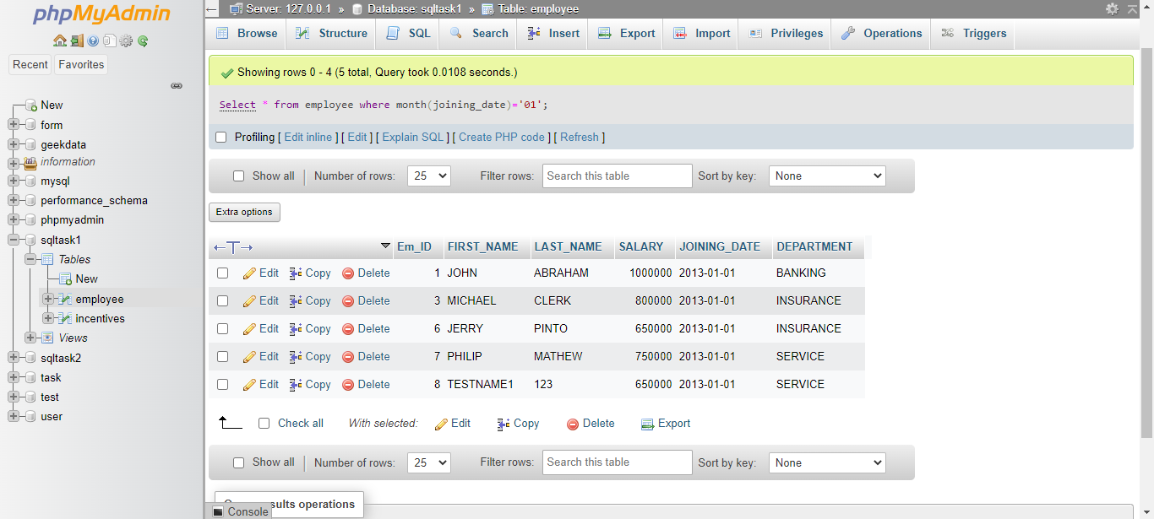

1. Get department, total salary with respect to a department from employee table  
   Order By total salary descending.

Ans: - SELECT DEPARTMENT, sum(SALARY) TOTAL_SALARY

FROM employee GROUP BY DEPARTMENT

ORDER BY TOTAL_SALARY DESC;

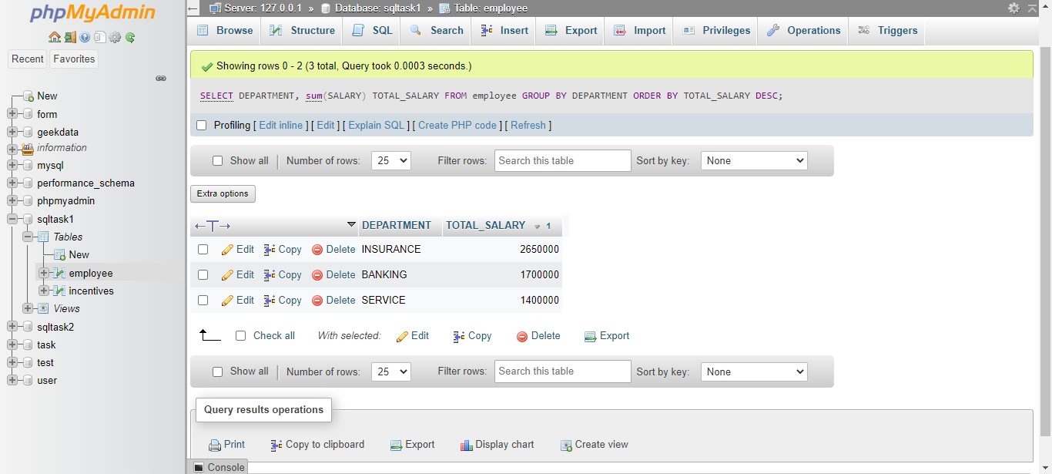

1. Get department wise maximum salary from employee table order by salary  
   ascending?

Ans: - SELECT DEPARTMENT,MAX(SALARY) MAXSALARY

FROM employee GROUP BY DEPARTMENT ORDER BY MAXSALARY ASC;

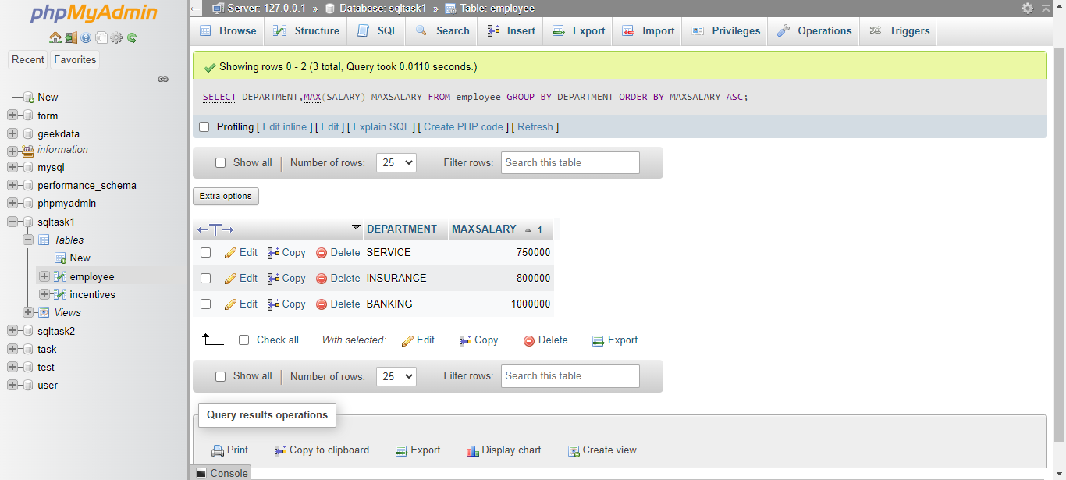

1. Select first_name, incentive amount from employee and incentives table for those  
   Employees who have incentives and incentive amount greater than 3000

Ans: - SELECT FIRST_NAME,INCENTIVE_AMT FROM employee A INNER JOIN incentives B ON A.Em_ID=B.EMPLOYEE_REF_ID AND INCENTIVE_AMT >3000;

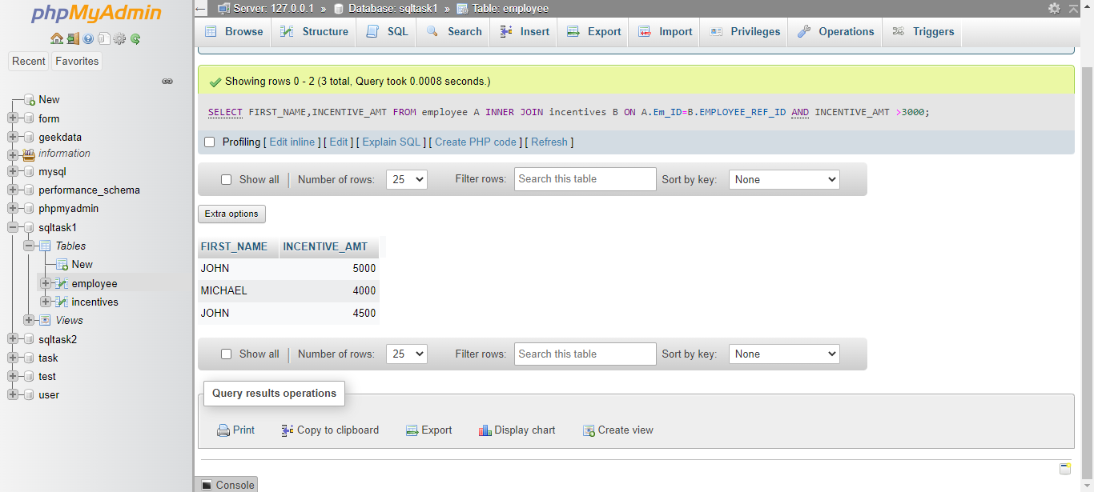

1. Select 2nd Highest salary from employee table.

Ans: - SELECT MAX(SALARY) FROM employee WHERE SALARY < (SELECT MAX(SALARY) FROM employee);

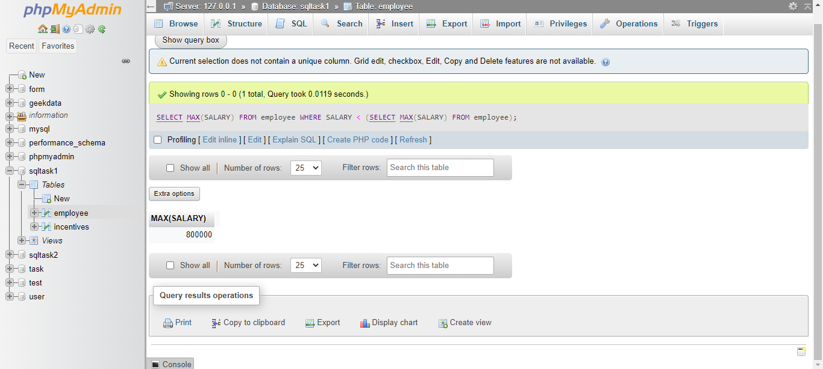

1. Select first_name, incentive amount from employee and incentives table for all  
   Employees who got incentives using left join.

Ans: - SELECT FIRST_NAME,NVL(INCENTIVE_AMT,0) FROM employee A RIGHT JOIN incentives B ON A.Em_ID=B.EMPLOYEE_REF_ID;

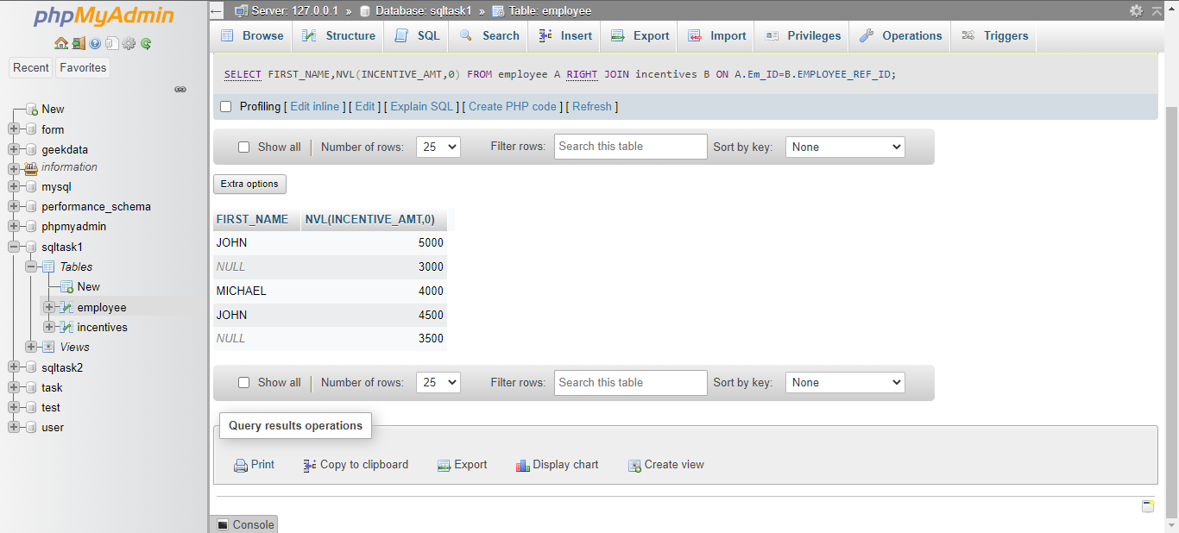

1. Create View OF Employee table in which store first name, last name and salary  
   only.

Ans: - CREATE VIEW employees_view AS

SELECT FIRST_NAME,LAST_NAME,SALARY

FROM employee ; SELECT FIRST_NAME,LAST_NAME,SALARY FROM employees_view;

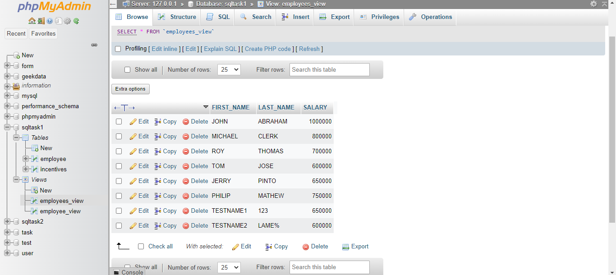

1. Create Procedure to find out department wise highest salary.

Ans: - SELECT DEPARTMENT, MAX(Salary)

FROM employee

GROUP BY DEPARTMENT;

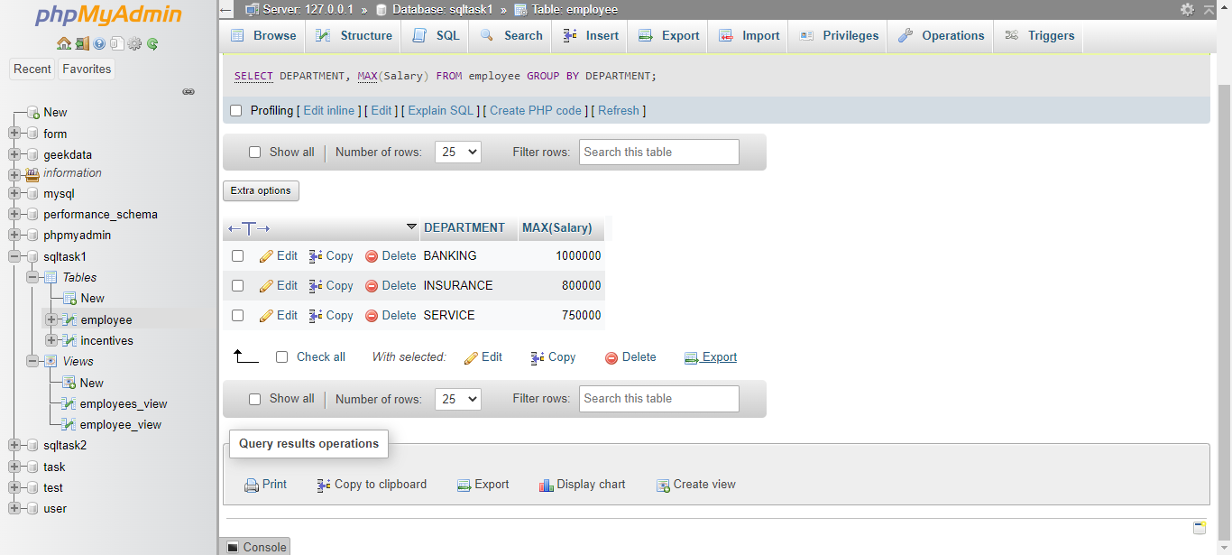

M)Create after Insert trigger on Employee table which insert records in view table.

Ans: - [CREATE](http://localhost/phpmyadmin/url.php?url=https://dev.mysql.com/doc/refman/8.0/en/create-trigger.html) [TRIGGER](http://localhost/phpmyadmin/url.php?url=https://dev.mysql.com/doc/refman/8.0/en/create-trigger.html) `insert_into_view` AFTER [INSERT](http://localhost/phpmyadmin/url.php?url=https://dev.mysql.com/doc/refman/8.0/en/insert.html) ON `employee` FOR EACH ROW [INSERT](http://localhost/phpmyadmin/url.php?url=https://dev.mysql.com/doc/refman/8.0/en/insert.html) INTO employee_view (FIRST_NAME,LAST_NAME,SALARY,DEPARTMENT,JOINING_DATE,Em_ID) [VALUES](http://localhost/phpmyadmin/url.php?url=https://dev.mysql.com/doc/refman/8.0/en/miscellaneous-functions.html%23function_values) (NEW.FIRST_NAME,NEW.LAST_NAME,NEW.SALARY,NEW.DEPARTMENT,NEW.JOINING_DATE,NEW.Em_id)

[INSERT](http://localhost/phpmyadmin/url.php?url=https://dev.mysql.com/doc/refman/8.0/en/insert.html) INTO `employee` (`Em_ID`, `FIRST_NAME`, `LAST_NAME`, `SALARY`, `JOINING_DATE`, `DEPARTMENT`) [VALUES](http://localhost/phpmyadmin/url.php?url=https://dev.mysql.com/doc/refman/8.0/en/miscellaneous-functions.html%23function_values) (NULL, 'MEHUL', 'GAJJAR', '750000', '2022-10-06', 'BANKING');

